Useful Tools, [14.10.2024 11:51]

use Action and Assessment to make sure the employees have learnt what the company desires them to:

(based on scenario) For example, for "Remember", action can be to teach knowledge about phishing attacks and for "Assessment" tests to check employees' recall of security protocols and the breach.

Useful Tools, [14.10.2024 15:39]

1. Knowledge (Remembering)

• Goal: Ensure all employees understand the basics of cybersecurity and the details of the breach.

2. Comprehension (Understanding)

• Goal: Help employees understand how the breach occurred and the steps taken to resolve it.

3. Application

• Goal: Enable employees to apply what they’ve learned in future scenarios.

4. Analysis

• Goal: Encourage employees to analyze weaknesses in the system and identify vulnerabilities.

5. Synthesis (Creating)

• Goal: Foster the creation of improved processes and protocols for cybersecurity.

6. Evaluation

• Goal: Encourage critical thinking on how well the organization’s security measures perform.

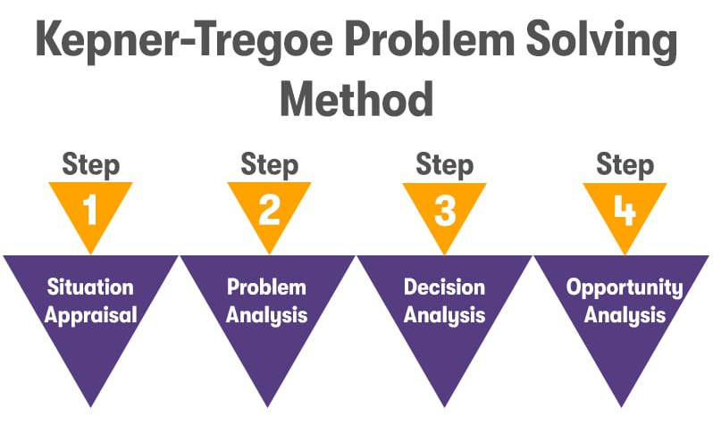

A little help on the given scenario:

Step 1. Clearly define your goal: Immediate action is required to stop further data loss and mitigate damage to the company’s reputation.

Step 2.

Bu rasmda \*\*Kepner-Tregoe Muammoni Hal qilish Metodi\*\*ning to'rt bosqichi ko'rsatilgan. Har bir bosqich o'ziga xos jarayonni ifodalaydi. Mana tarjimasi:

1. \*\*1-bosqich: Voqeani baholash\*\* (Situation Appraisal)

- Voqeani umumiy baholash va qaysi muammo yoki vaziyatni hal qilish kerakligini aniqlash.

BIRINCHI O’RINDA TEZDA ma’lumotlarni tarqalishini saqlab qolish. Serverni o’chirish gap tamom va salom. Keyin qolgan ishni qilish

2. \*\*2-bosqich: Muammoni tahlil qilish\*\* (Problem Analysis)

- Muammoning aniq sabablarini aniqlash va uni tushunish.

Xodimlarning savodsizligi. Fishing.

3. \*\*3-bosqich: Qaror qabul qilish tahlili\*\* (Decision Analysis)

- Eng yaxshi qaror yoki yechimni tanlash uchun imkoniyatlarni baholash va variantlarni ko'rib chiqish.

4. \*\*4-bosqich: Imkoniyat tahlili\*\* (Opportunity Analysis)

- Voqeadan kelib chiqadigan imkoniyatlarni aniqlash va ularni qanday qilib eng yaxshi foydalanishni rejalashtirish.

Bu usul murakkab muammolarni hal qilishda aniq va tizimli yondashuvni taklif qiladi.